Email Spam Classifier
Email Spam Classifier Report
Author: Artheesh E (Team1)
Project Type: Individual Project

EXECUTIVE SUMMARY:
This project focuses on building an Email Spam Classifier using Machine Learning. The system identifies whether an email is spam or not by analyzing its content. It uses Natural Language Processing (NLP) techniques and algorithms like Naive Bayes, Logistic Regression, and SVM for classification.
The model is trained using standard datasets and provides accurate results. This project helps in automatically filtering unwanted emails and can be used in real-time email systems. It also shows how machine learning can be applied to solve real-world problems.

PROJECT OVERVIEW:
Objective:
The objective of this project is to develop a Machine Learning-based Email Spam Classifier that can automatically identify and classify emails as spam or legitimate (ham) using NLP techniques.
Scope:
This project focuses on analyzing email text content to detect spam messages. It can be used in email systems for automatic filtering and can be extended to detect phishing or fraudulent emails. The system is designed to be simple, fast, and scalable.
Key Features:
• Classifies emails as spam or ham
• Uses NLP techniques for text processing
• Supports real-time email classification
• High accuracy with low error rate
• Can visualize important spam-related keywords

TECHNICAL IMPLEMENTATION:
Architecture:
The system follows a simple Machine Learning pipeline architecture:
- Data Collection: Email datasets are collected from sources like SpamAssassin or UCI datasets.
- Data Preprocessing: Text is cleaned by removing stopwords, punctuation, and unnecessary symbols.
- Feature Extraction: Techniques like Bag of Words or TF-IDF are used to convert text into numerical format.
- Model Training: Machine Learning algorithms such as Naive Bayes, Logistic Regression, and SVM are trained on the processed data.
- Model Evaluation: The model is tested using accuracy, precision, and recall metrics.
- Prediction: New emails are analyzed and classified as spam or ham in real-time.
Technology Stack:
- Programming Language: Python
- Libraries:
- scikit-learn
- pandas
- NumPy
- NLTK / spaCy
- Matplotlib / Seaborn
- • Algorithms:
- Naive Bayes
- Logistic Regression
- Support Vector Machine (SVM)
- • Datasets:
- SpamAssassin Dataset
- UCI SMS Spam Collection Dataset
- Kaggle Spam Datasets

PERFORMANCE METRICS
- Accuracy: Measures the overall correctness of the model in classifying emails as spam or ham.
- Precision: Indicates how many emails predicted as spam are actually spam.
- Recall: Measures how many actual spam emails are correctly identified by the model.
- F1-Score: Combines precision and recall to give a balanced performance measure.
- Confusion Matrix: Shows the number of correct and incorrect predictions for spam and ham classes.

SOURCE CODE IMPLEMENTATION (Screenshot):
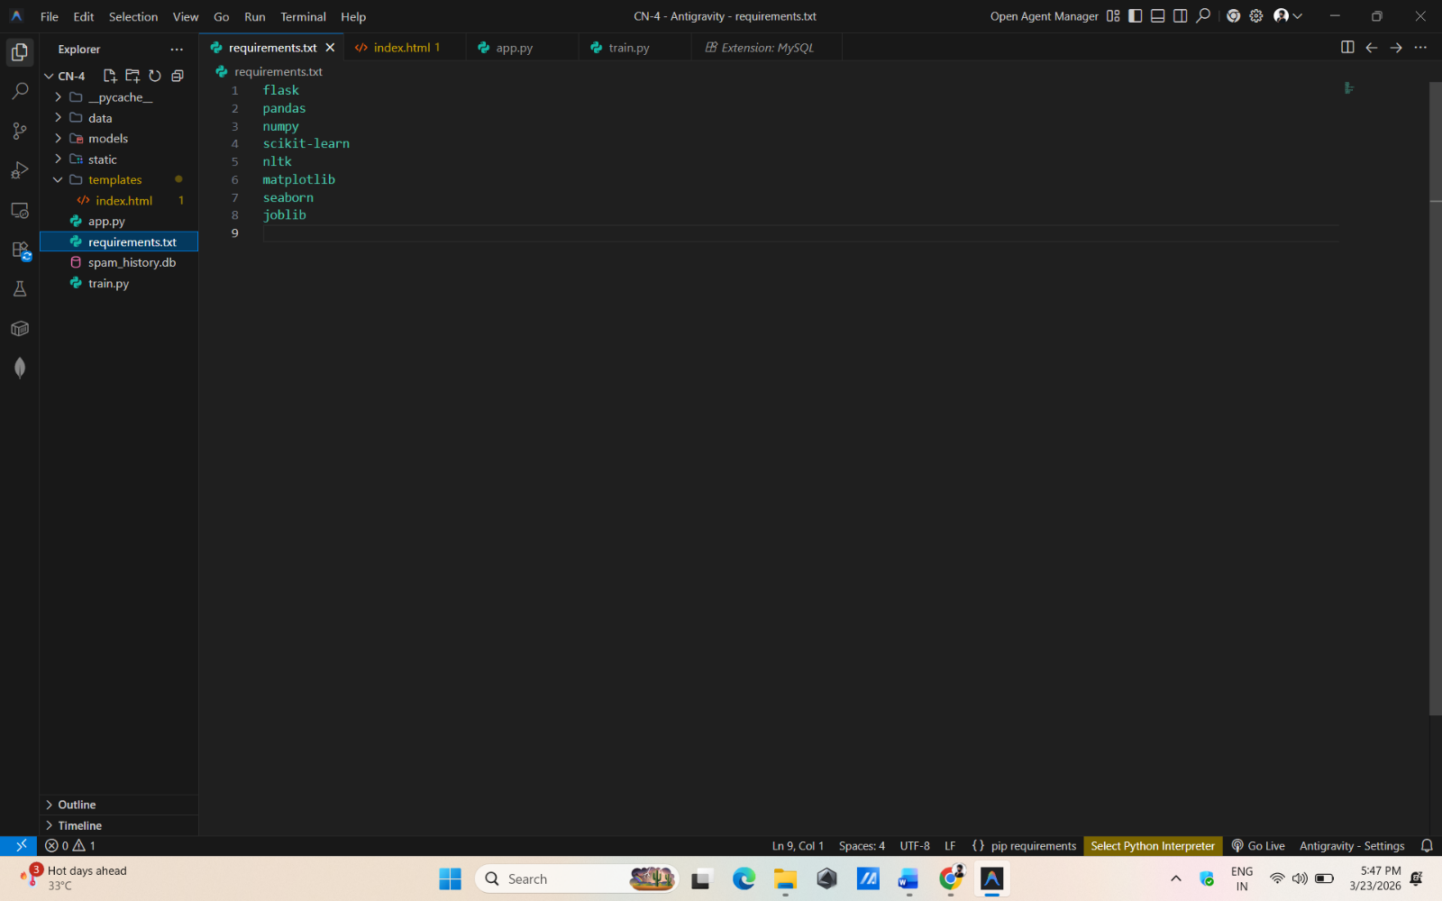
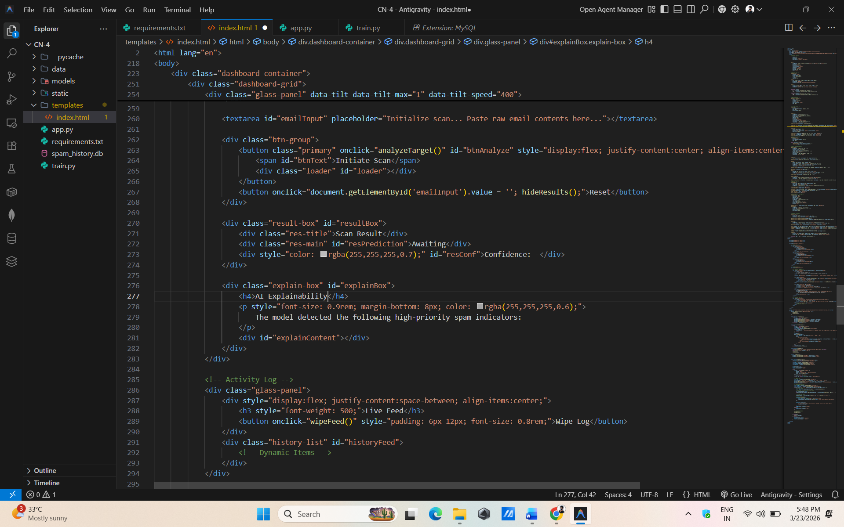

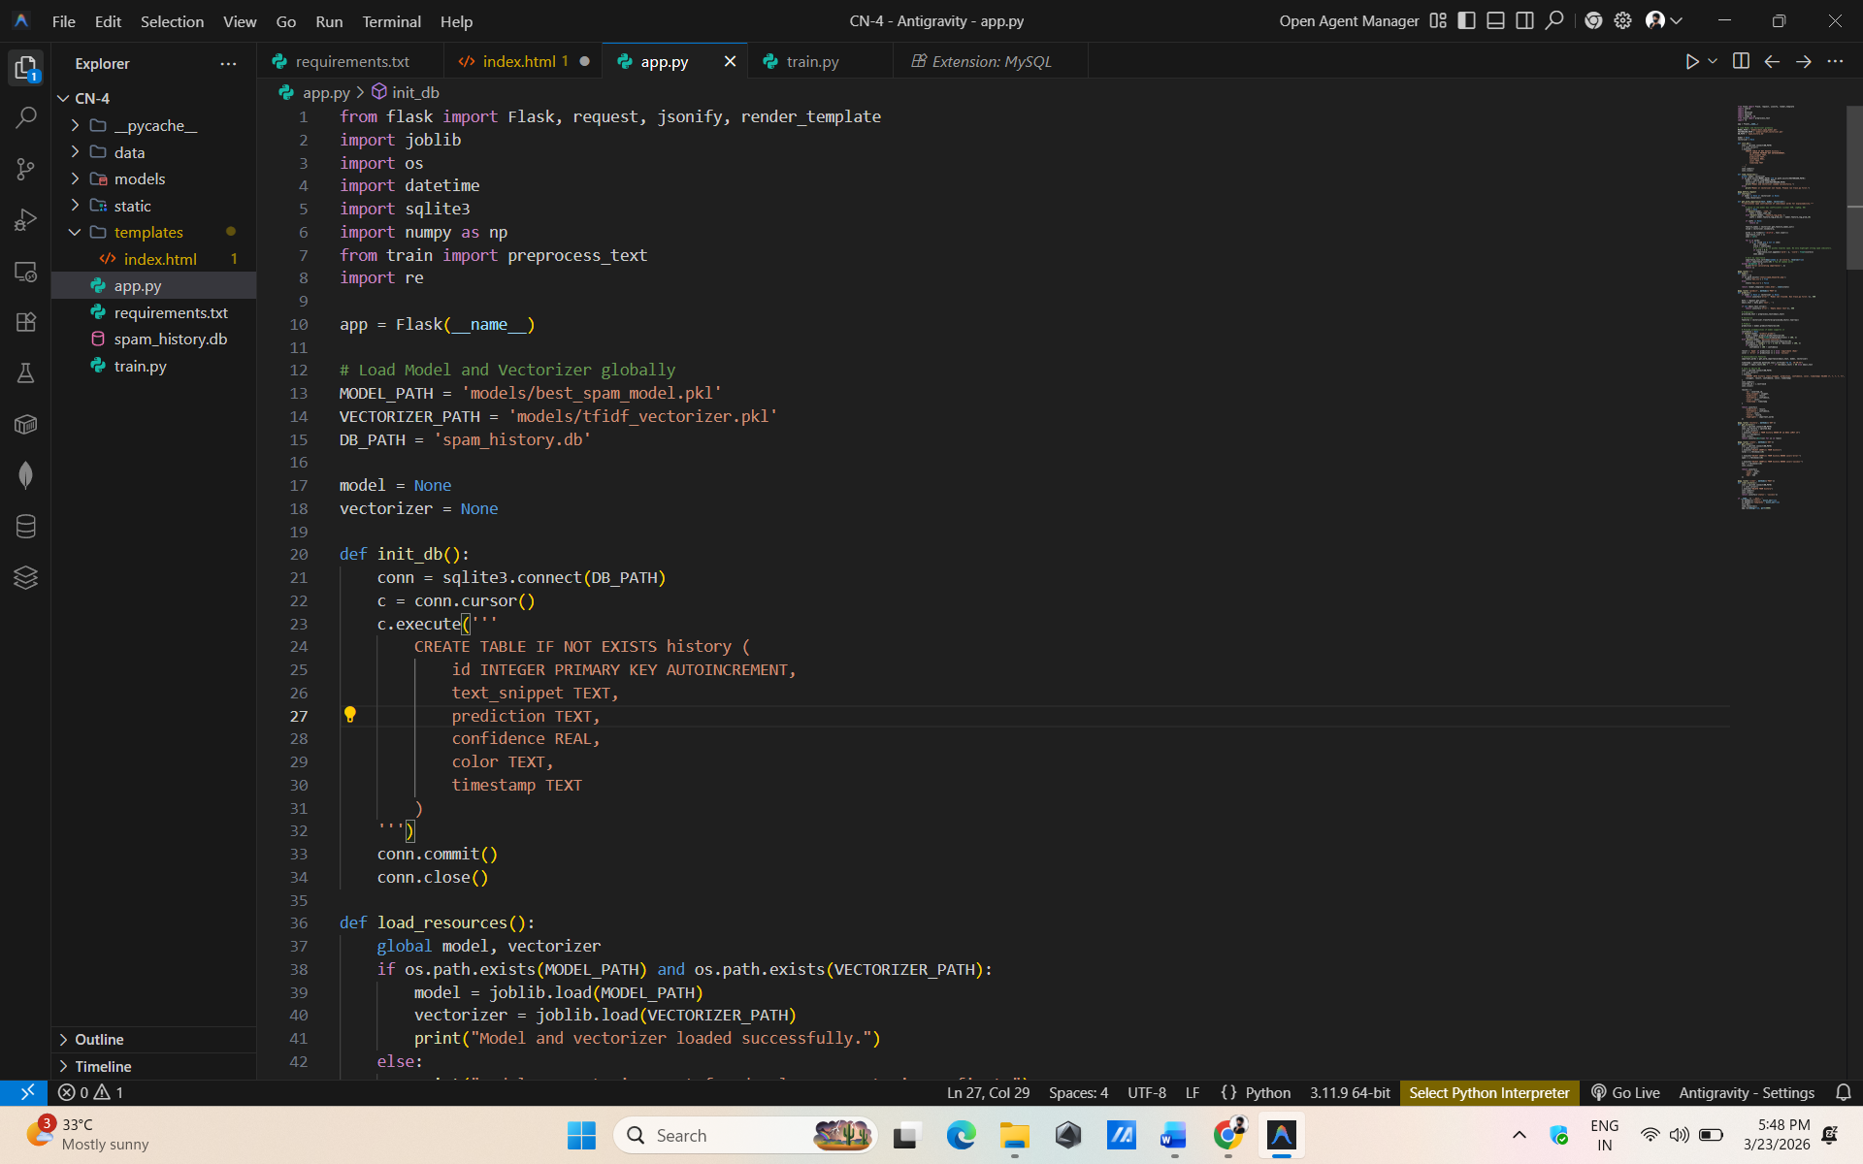
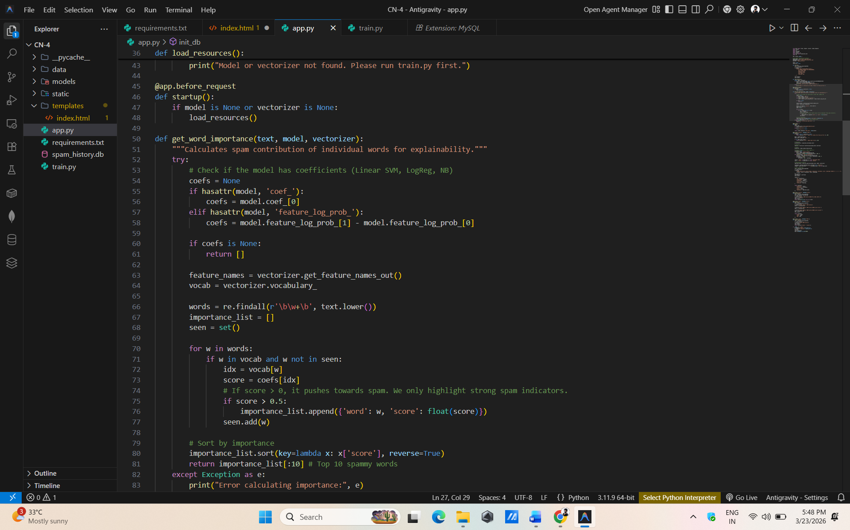

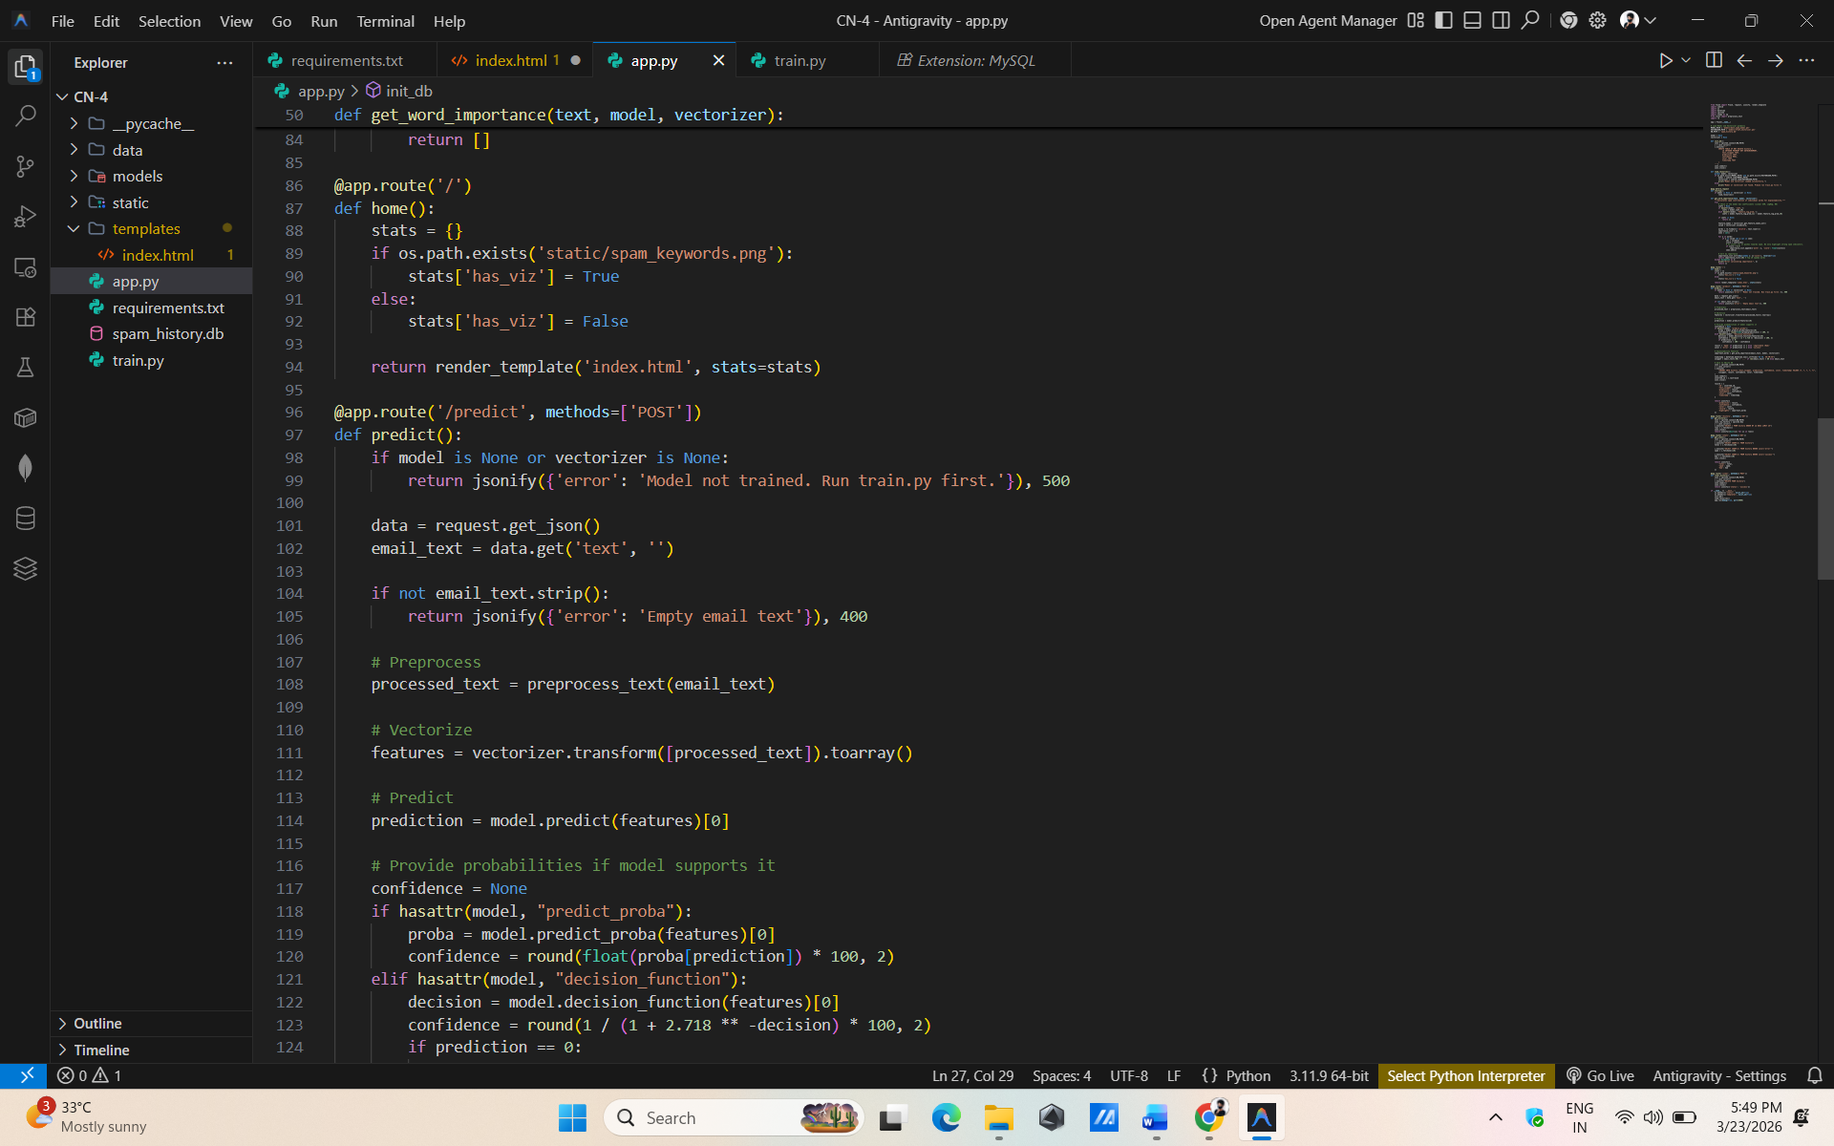
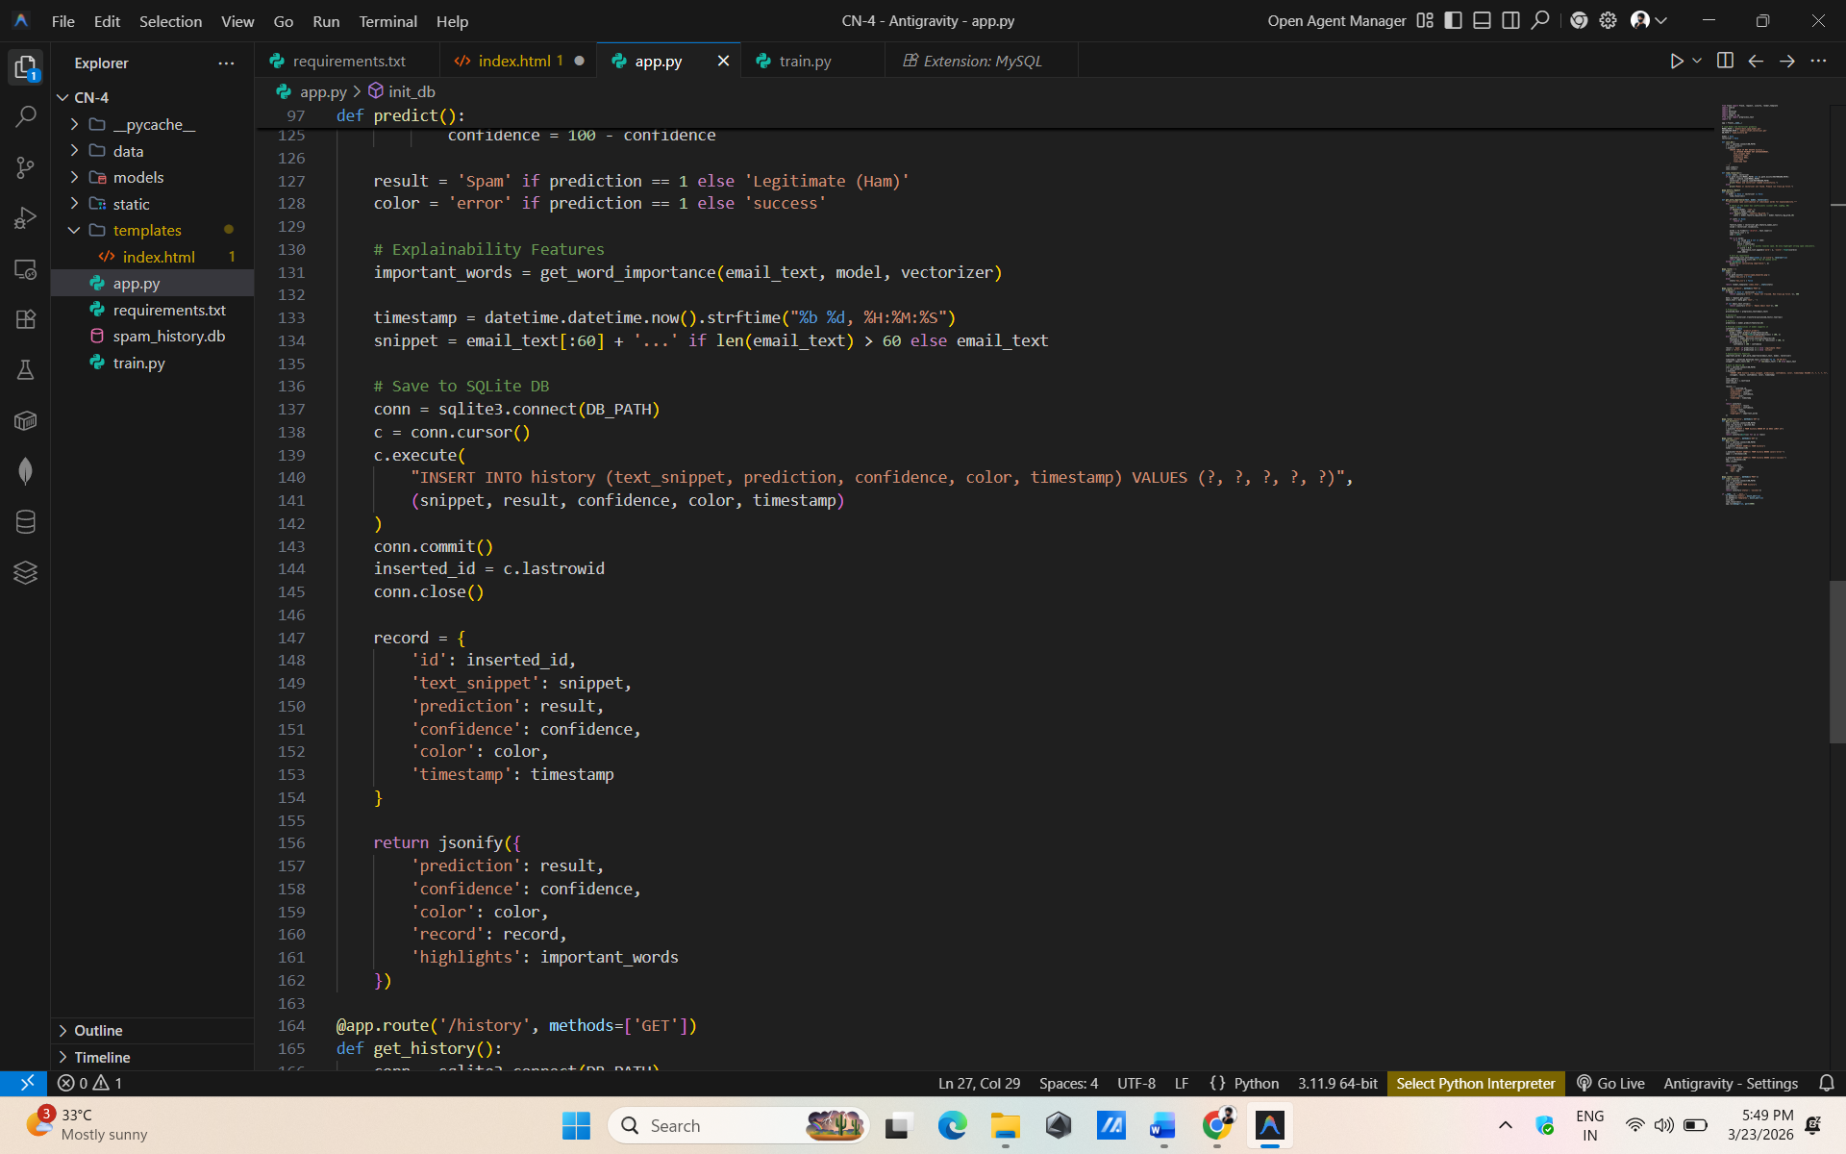

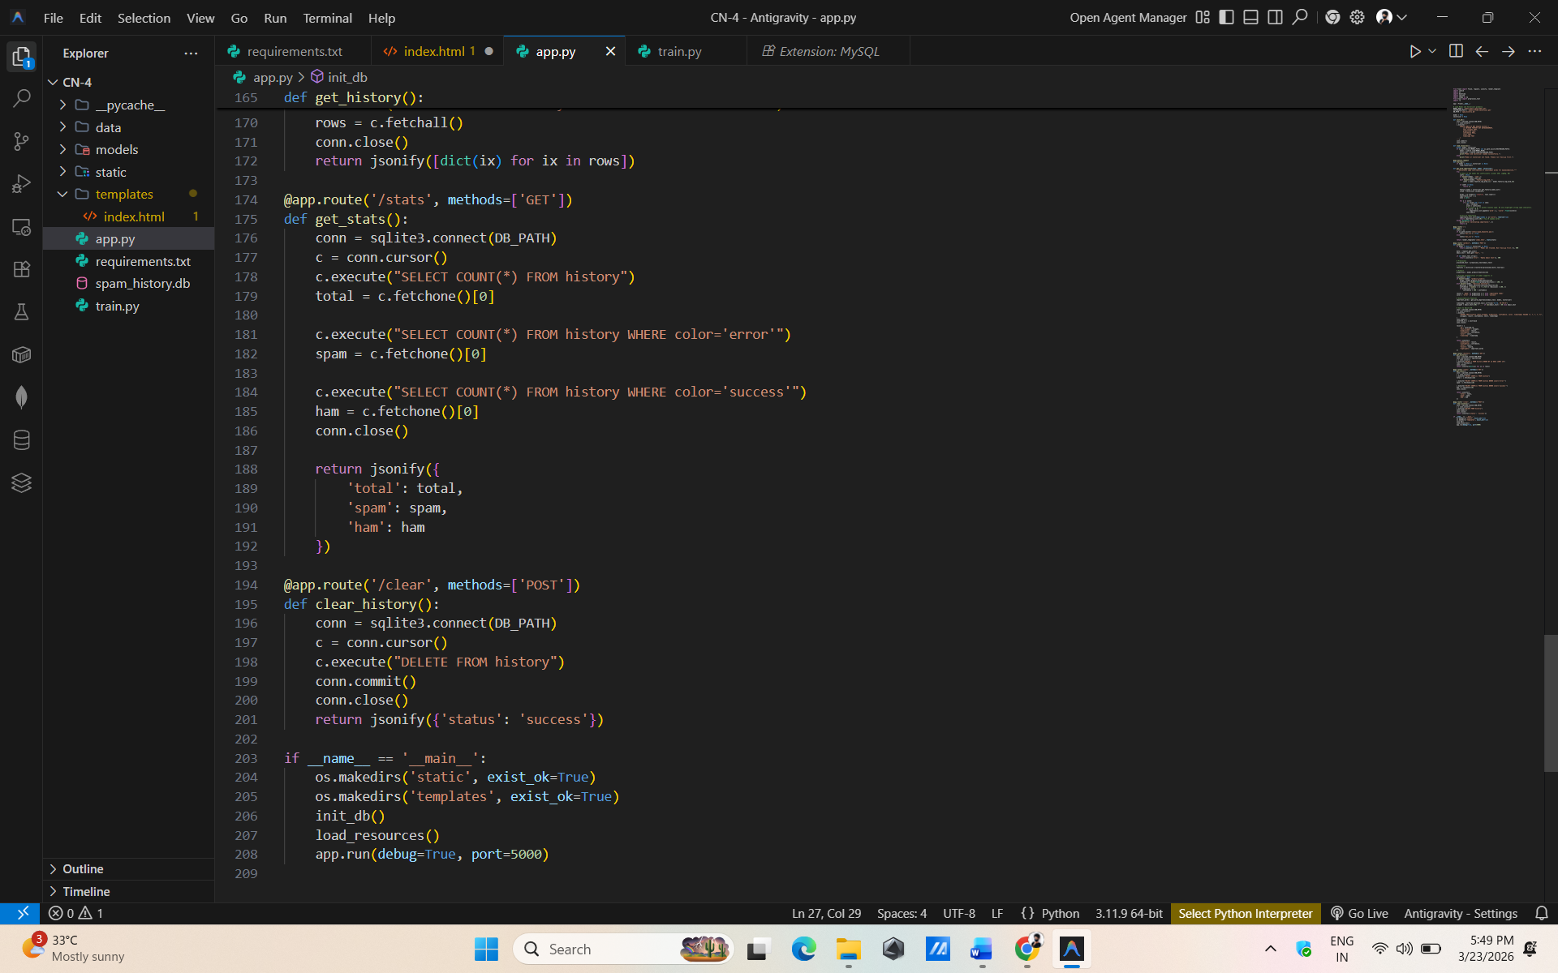
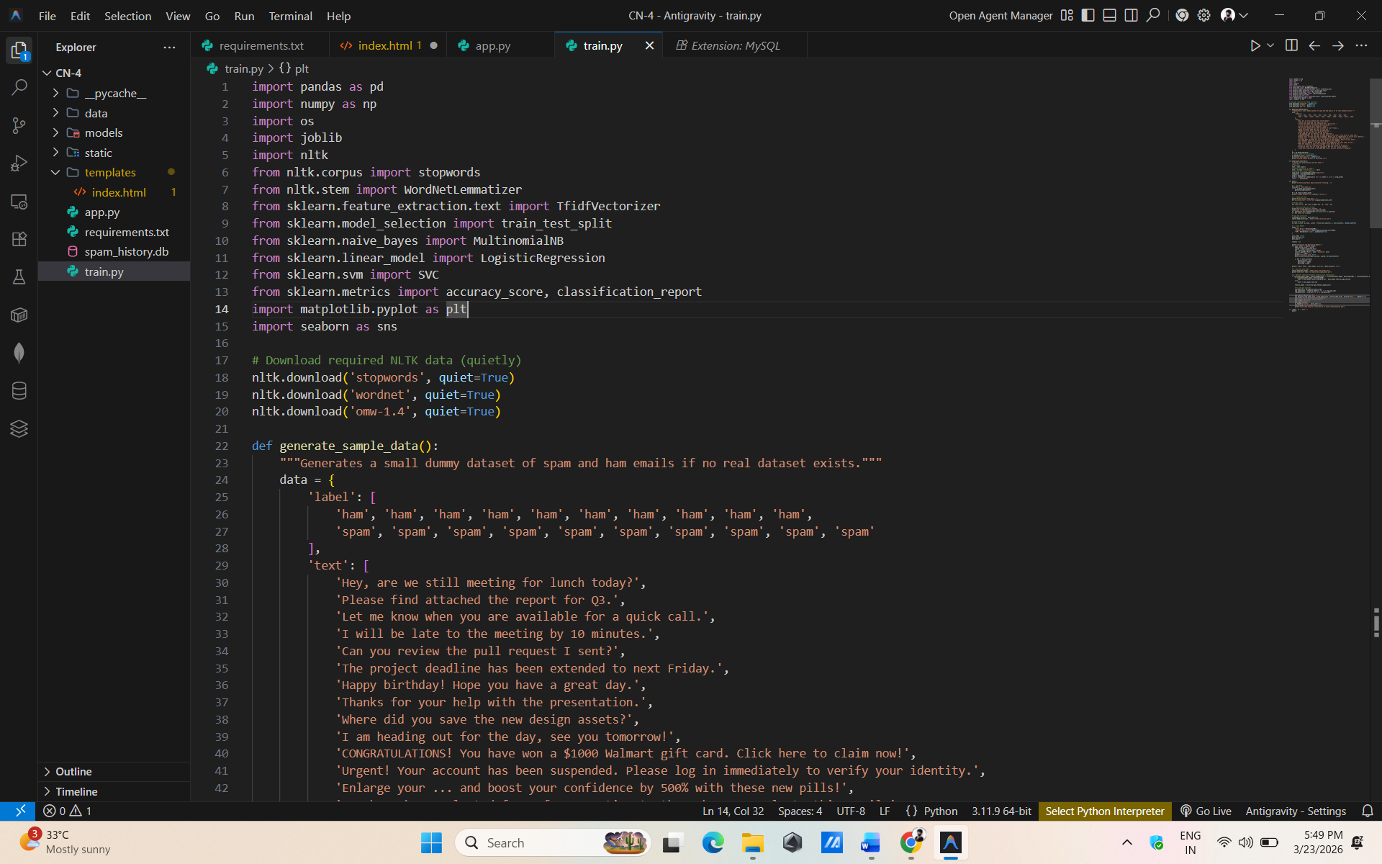

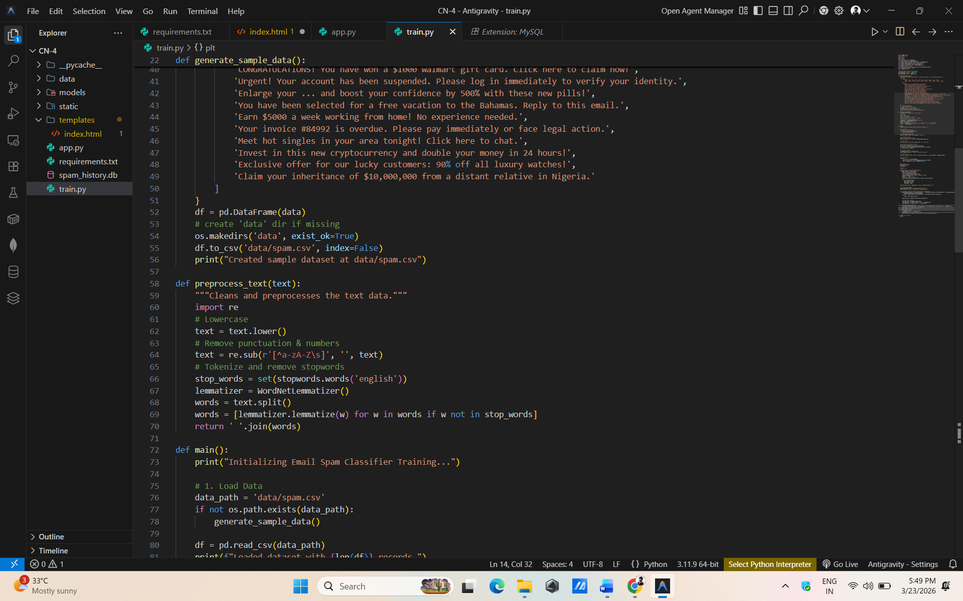

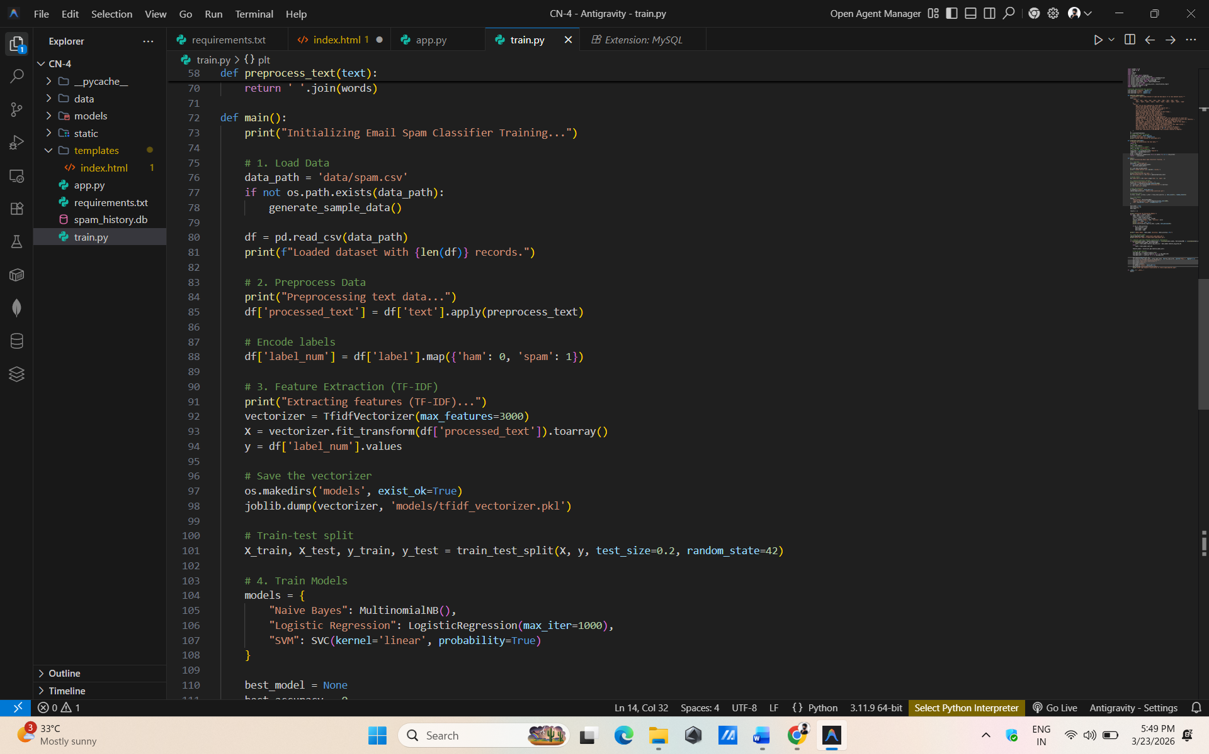

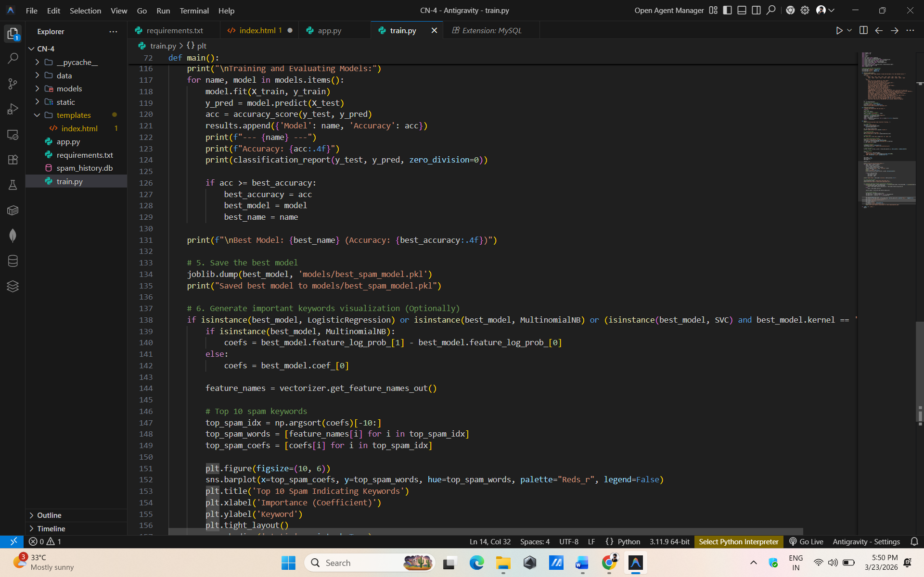

Result:
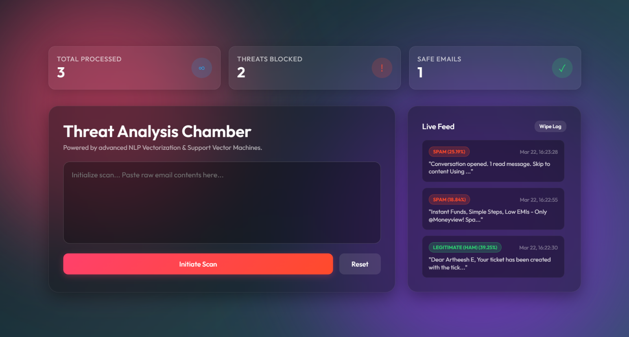

OUTCOMES:
Immediate Benefits:
• Automatically filters spam emails and reduces inbox clutter
• Saves time by preventing users from manually checking unwanted emails
• Improves email security by identifying suspicious messages
• Provides fast and real-time email classification
• Enhances user experience with accurate spam detection

Conclusion:
The Email Spam Classifier project successfully demonstrates how Machine Learning and NLP can be used to identify and filter unwanted emails. The system provides accurate and efficient classification of emails as spam or ham, improving email security and user experience. This project also serves as a strong foundation for further enhancements such as phishing detection and advanced threat analysis.

